
QUALITY MANAGEMENT SYSTEM
DAN Quality Management System
Quality Management Plan

Document Control
Document No. | 01-DAN-PLN-QMS-000001-QMP | Revision | R00
Issue Date | June 2026 | Classification | Controlled — Internal
Document Owner | HSE Department | Page Format | US Letter
Approval
Prepared By | Reviewed By | Approved By
HSE Representative  Signature / Date | Competent Person (HSE)  Signature / Date | Project Director / Manager  Signature / Date

Table of Contents

How to Use This Plan
This Quality Management Plan (QMP) defines the processes, standards, methodologies and responsibilities necessary to ensure that project deliverables meet DAN's quality requirements and those of the Client / Owner. It is a project-level plan issued under, and governed by, the DAN Quality Management Manual (01-DAN-MAN-QMS-000001) and is structured to the ISO 9001:2015 high-level structure so that it satisfies the Client's Quality Management Review requirements.
The plan is completed and maintained for each project. Fields shown in square brackets [ ] are project-specific and are populated at project mobilisation. Where this plan refers to "the Contractor", the obligation is delivered by DAN through its project delivery chain — DAN (Employer / Client) directing the Project Management Consultant (PMC), which manages and supervises the Contractor and its subcontractors and vendors.

1. Scope, Normative References and Terms & Definitions

1.1 Project Identification
Field | Detail
Project name | [Project name]
Contract number | [Contract number]
Client / Owner | [Client / Owner]
Employer | DAN Company
Project Management Consultant (PMC) | [PMC]
Main Contractor | [Main Contractor]
Applicable phases of the project | [Design / Procurement / Construction / Testing & Commissioning / Handover — select as applicable]

1.2 Scope
This plan applies to all quality-affecting activities undertaken on the project across the applicable phases listed above — from design and procurement through construction, testing and commissioning, to completion and handover — by DAN, the PMC, the Contractor and their subcontractors and vendors.

1.3 Normative References
The following references are applicable to this project:
- ISO 9001:2015 — Quality management systems — Requirements.
- DAN Quality Management Manual (01-DAN-MAN-QMS-000001).
- The Client / Owner quality requirements and Quality Management Review criteria.
- The project contract, specifications and employer's requirements.
- Applicable Saudi codes (SBC) and the referenced international design and workmanship standards.
- The Saudi Labour Law of the Ministry of Human Resources and Social Development.
- [Any additional project-specific standards and regulatory references].

1.4 Terms and Definitions
Term | Definition
QMP | Quality Management Plan — this document.
QMS | Quality Management System.
QMR | Quality Management Review conducted by / on behalf of the Client.
ITP | Inspection and Test Plan.
WIR / MIR | Work / Material Inspection Request.
NCR | Non-Conformance Report.
CAPA | Corrective Action / Preventive Action.
RFI | Request for Information.
KPI | Key Performance Indicator.
PMC | Project Management Consultant.
Client / Owner | The party for whom the project is delivered; the recipient of the completed works.

2. Context of the Organization

2.1 Mission, Vision, Core Values and Commitment to Quality
DAN is a construction project-delivery organisation. Its mission is to deliver building, civil and infrastructure projects safely, on time, within budget and to the required quality; its vision is to be recognised for delivery excellence and reliability. DAN's core values — integrity, accountability, collaboration and continual improvement — underpin an unconditional commitment to quality: to meet or exceed the Client's requirements and applicable standards on every deliverable.

2.2 Interested Parties and Their Requirements
Interested party | Key quality requirements
Client / Owner | Compliance with contract, specifications and quality requirements; defect-free, fit-for-purpose deliverables; transparent reporting.
End users / occupants | Safe, durable, functional and maintainable facilities.
Regulatory authorities | Compliance with Saudi codes, permits and statutory requirements.
PMC | Clear quality criteria, timely submissions, inspectable work fronts.
Contractor / subcontractors / vendors | Defined acceptance criteria, ITPs, timely inspection and approval.
DAN employees | Competent resourcing, clear responsibilities and procedures.

2.3 Internal and External Factors
Internal and external factors that could impact the quality of delivered products are identified, monitored and reviewed:
- Internal — resource competency and availability, design maturity, procurement lead times, interface management, information-management maturity.
- External — Client requirement changes, regulatory changes, market availability of compliant materials, weather and site conditions, subcontractor and vendor performance.

2.4 Quality Risks and Opportunities
Potential risks that could compromise quality — and opportunities for improvement — are identified and managed through the risk and opportunities register (see Section 4.1), which is reviewed at defined intervals and updated as the project progresses.

3. Leadership
DAN's leadership — the Chief Executive Officer (CEO), the Chief Development Officer (CDO) and the Delivery Director, supported by the Quality function — is committed to the development, implementation and continual improvement of the QMS on the project, and demonstrates this commitment by setting the Quality Policy and objectives, providing resources, and holding the delivery chain accountable for quality outcomes.

3.1 Quality Policy
DAN is committed to delivering projects that consistently meet the Client's requirements and applicable statutory, regulatory and standard requirements; to setting and reviewing measurable quality objectives; to providing competent people and adequate resources; and to continually improving the effectiveness of the Quality Management System. The Quality Policy is communicated, understood and applied across the project and is available to interested parties.

3.2 Quality Objectives and KPIs
Quality objective | KPI | Target
Deliver conforming work first time | First-time inspection pass rate (WIR/MIR approved vs. submitted) | ≥ 90 %
Control non-conformity | NCRs closed within target period | ≥ 95 % within 30 days
Timely submittal management | Submittals approved vs. submitted on first review | ≥ 85 %
Competent quality resourcing | Quality-personnel training hours delivered vs. planned | ≥ 95 %
Calibration integrity | Measuring & test equipment within calibration | 100 %
Client satisfaction | Client / QMR satisfaction score | ≥ 4 / 5
Note: Objectives are SMART (specific, measurable, achievable, relevant and time-bound) and are reviewed at Management Review (see Section 7.5).

3.3 Organization Chart and Interfaces
The quality reporting hierarchy runs from the CEO through the CDO and the Delivery Director to the Quality Manager, who leads the project quality function independently of production. The quality function interfaces with the PMC and, through it, with the Contractor's quality organisation and with subcontractors and vendors.
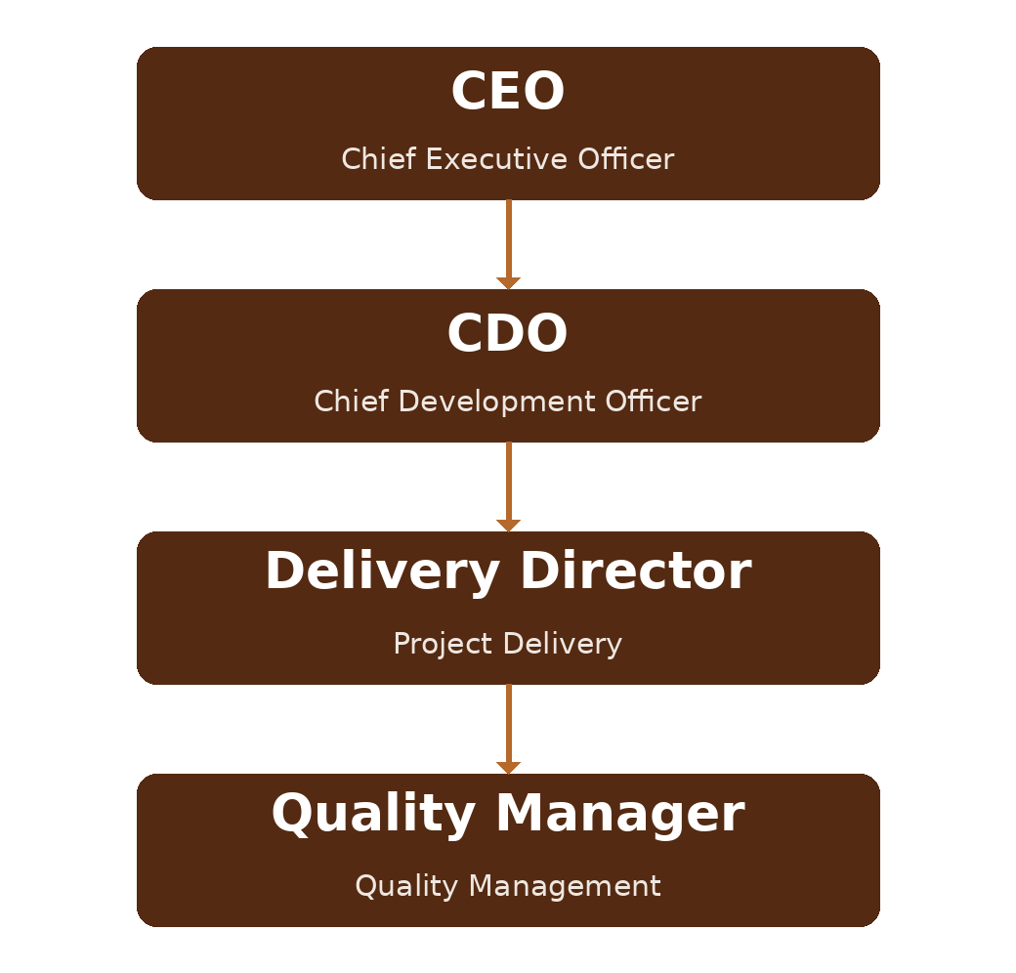
Figure 3.1 DAN quality reporting hierarchy
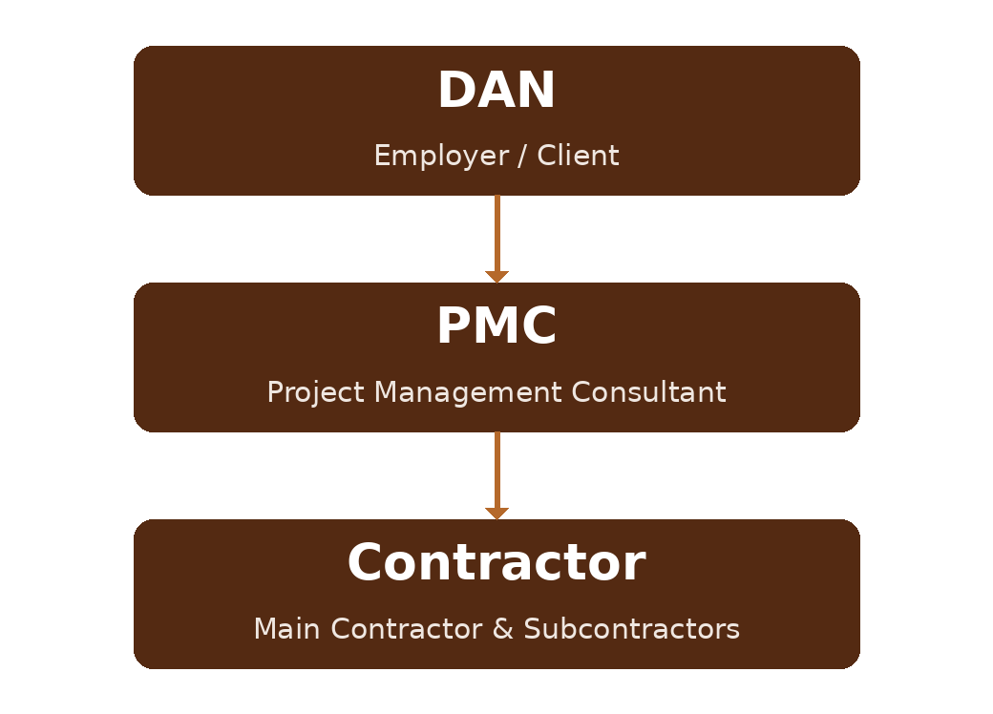
Figure 3.2 Project delivery structure and quality interfaces (DAN → PMC → Contractor → subcontractors / vendors)

3.4 Roles and Responsibilities
Role | Quality responsibilities
Delivery Director | Owns project delivery and quality outcomes; approves the QMP; provides resources; chairs Management Review.
Quality Manager | Develops, implements and maintains the QMP and QMS on the project; independent authority to stop non-conforming work; manages audits, NCRs and reporting.
Project / QA/QC Manager | Implements ITPs, inspections, submittal and NCR processes; verifies Contractor quality performance.
PMC — Quality Lead | Supervises Contractor quality delivery; reviews submittals and inspection requests; reports to DAN.
Contractor | Executes the works to specification; raises WIR/MIR; maintains records; closes NCRs.
Document Controller | Controls documented information and records.

4. Planning

4.1 Risk and Opportunities Register
A risk and opportunities register is established and maintained for quality. Each entry records the risk or opportunity, its cause, likelihood and impact, the control or action, the owner and the due date, and is reviewed and updated at defined intervals through the project lifecycle.

4.2 Quality Objectives (SMART)
The measurable quality objectives and KPIs defined in Section 3.2 are cascaded to the responsible functions, resourced, tracked and reported. Each objective is specific, measurable, achievable, relevant and time-bound.

4.3 Change Management
A change-management process governs changes to design, scope, specification and the QMS itself. Changes are recorded, assessed for quality impact, approved by the appropriate authority, communicated to affected parties, and reflected in the ITPs, procedures and documented information. Field changes follow the field-change procedure (Section 6.3).

5. Support

5.1 Project Resources
The resources necessary to implement, maintain and improve the QMS on the project — people, infrastructure, work environment, monitoring and measuring resources, and organisational knowledge — are determined, provided and maintained.

5.2 Competency
Job titles performing activities affecting quality, and the minimum competency required for each, are defined:
Job title | Minimum required competency
Quality Manager | Degree in engineering / quality; recognised quality qualification (e.g. CQI/IRCA); ≥ 10 years, incl. construction quality management; lead-auditor certification.
QA/QC Manager / Engineer | Engineering degree; ≥ 5 years construction QA/QC; knowledge of ITPs, codes and inspection.
QA/QC Inspector | Diploma / trade qualification; discipline inspection certification (e.g. welding, civil, MEP) as applicable.
Document Controller | Relevant qualification; competence in the project's document-management system.

5.3 Training
Training needs of personnel performing quality-affecting activities are identified, a training plan is established, and training is delivered and recorded. The effectiveness of training is evaluated and training hours are tracked as a KPI (Section 3.2).

5.4 Infrastructure and Work Environment
The workplace and associated facilities, equipment, hardware, software and support administrative services required to deliver conforming work are listed, provided and maintained — including offices and site facilities, inspection and survey equipment, testing laboratories (in-house or accredited third party), and the project information-management platform.

5.5 Adherence to Labour Law
DAN and its delivery chain fully adhere to the Saudi Labour Law of the Ministry of Human Resources and Social Development, including working-hours, welfare and workforce-management provisions, as these underpin the competence and availability of resources affecting quality.

5.6 Communication
The processes of the QMS are communicated effectively across the project. DAN's points of contact, the frequency of contact, their responsibilities and the communication tools are determined:
Interface | DAN point of contact | Frequency | Tool
Client / QMR | Delivery Director / Quality Manager | Per QMR cycle / monthly | Review meetings, reports
PMC | Quality Manager / QA/QC Manager | Weekly | Meetings, correspondence, EDMS
Contractor | QA/QC Manager | Daily / weekly | WIR/MIR, site meetings, EDMS
Internal (DAN) | Quality Manager | Weekly / monthly | Management Review, dashboards

5.7 Documented Information
Documented information is managed under document control — created, identified, reviewed, approved, distributed, version-controlled, protected and retained. Controlled documents and records include, as a minimum:
- Quality Policy and objectives, and this QMP.
- Inspection and Test Plans (ITPs).
- Inspection and test reports (WIR/MIR results, test certificates).
- NCRs and corrective actions (CAPA).
- Submittal, RFI and field-change logs.
- Audit reports and Management Review records.

5.8 Organizational Knowledge
Internal and external sources of knowledge necessary to deliver the project are identified and maintained — lessons learned, standards and codes, supplier and material data, and expert input — and are made available to those who need them.

6. Operation

6.1 Process Establishment
Processes are established and controlled for each applicable phase — design, procurement, construction, and testing and commissioning — with defined inputs, outputs, controls, responsibilities and interfaces.

6.2 Acceptance Criteria
Acceptance criteria for each process and deliverable are defined in the contract specifications, the referenced standards and the ITPs. Work is inspected and tested against these criteria and is not progressed or covered up until the required inspection has been witnessed and approved.

6.3 Construction and Monitoring Procedures
The following construction and monitoring procedures are developed and applied on the project:
- Inspection and Test Plans (ITPs) with hold, witness and review points, and WIR/MIR processing.
- Testing and commissioning procedure.
- Construction completion and turnover (handover) procedure.
- Non-conformity and corrective-action procedure (NCR / CAPA).
- Request for Information (RFI) procedure.
- Field-change procedure.
- Material and equipment control, and measuring & test-equipment calibration control.

6.4 Evidence of Compliance and Records
Records demonstrating conformity of completed work — approved WIRs/MIRs, test certificates, survey and calibration records, closed NCRs, and as-built documentation — are compiled, maintained and made available for the Client's Quality Management Review and for handover.

7. Performance Evaluation

7.1 Monitoring and Measurement
What needs to be measured and monitored is identified, together with the methods for monitoring, measurement, analysis and evaluation, and when each is performed — so that the results are valid. Quality KPIs (Section 3.2) are measured at defined frequencies.

7.2 Client Perception and Satisfaction
Methods to monitor and measure the Client's perception and satisfaction are defined — including QMR outcomes, satisfaction surveys and feedback at review meetings — and the results feed the improvement process.

7.3 Internal and External Audit Programme
An internal and external audit programme is developed and maintained, based on the status and importance of processes and previous results. Audits are planned, conducted by competent auditors independent of the audited activity, reported, and their findings tracked to closure.

7.4 QA/QC Reporting
Quality performance is reported to DAN and the Client through weekly and monthly QA/QC reports:
Weekly QA/QC report — summary of:
- NCRs issued / closed within the week.
- WIR/MIR attended vs. planned.
- Submittals approved / rejected.
- Training hours provided to construction and quality personnel.
- Defective / rejected equipment, materials or deliverables at the job site.
- Contractor quality-personnel listing.
Monthly QA/QC report — analysis and evaluation of:
- Updated NCR log with root-cause analysis and corrective actions, and estimated cost / schedule impact of repair or rework dispositions.
- Summary of WIR/MIR for the month; approved and rejected submittals; defective / rejected items.
- Engineering-waiver requests (activities not adhering to the QMP) and their status.
- Quality KPIs and their status; contractor quality personnel; vendor information and planned vendor surveys.
- Process-improvement narrative; planned, completed and in-progress quality audits; updated calibration log.

7.5 Management Review
Management Review is conducted at planned intervals. Inputs include audit results, KPI and objective performance, NCR and CAPA status, Client feedback and satisfaction, risks and opportunities, and change. Outputs are decisions and actions to improve the QMS, the deliverables and resourcing, and are recorded and tracked.

8. Continual Improvement

8.1 Improvement Process
A procedure for continual-improvement management is applied. Nonconformities, audit findings, KPI trends, Client feedback and lessons learned are analysed to identify improvements, which are implemented through corrective action and change management and verified for effectiveness.

8.2 Resources for Improvement
The project resources required to implement improvements to the QMS are identified and provided, so that improvement actions are completed and sustained.

Revision History
Rev. | Date | Description of Change | Approved By
R00 | June 2026 | First issue — DAN Quality Management Plan, structured to the Client Quality Management Review requirements and the ISO 9001:2015 high-level structure, and aligned to the DAN Quality Management Manual (01-DAN-MAN-QMS-000001). | Delivery Director

